In this screen shot 1 - 8 questions

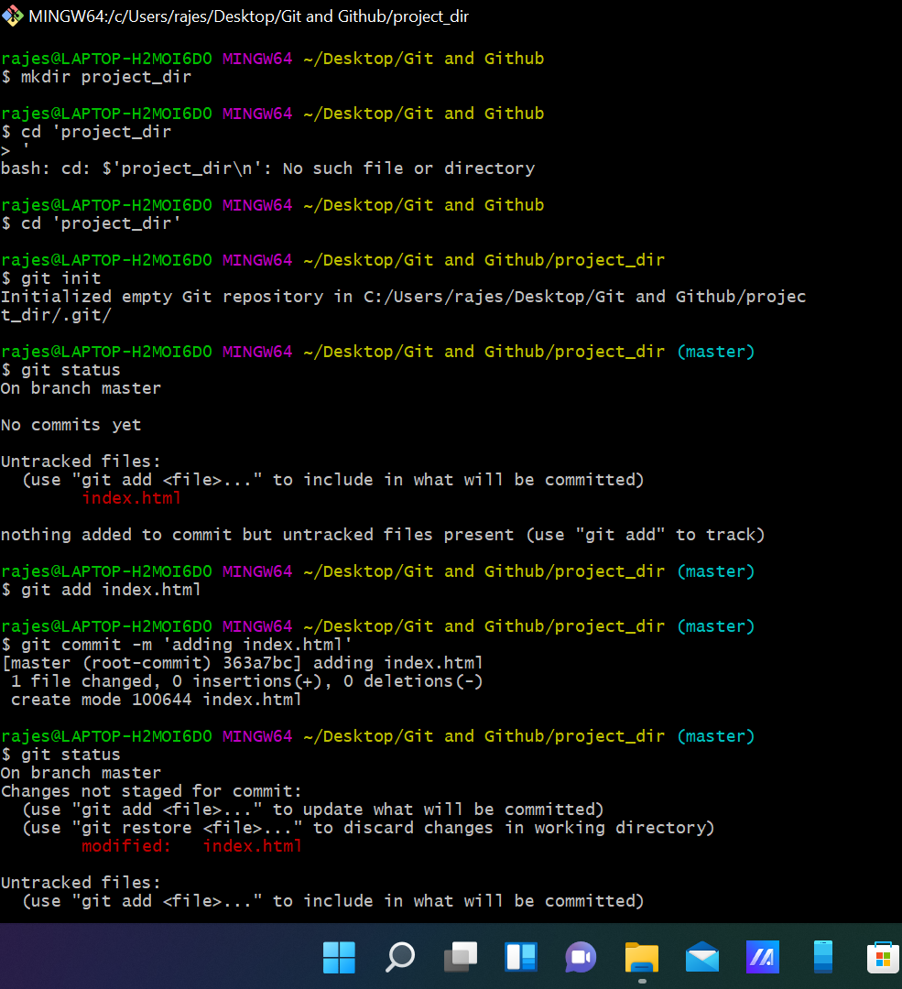

I have created folder Git and Github and proceded with mkdir and initiated project_dir directory and added index.html file manually and checked git status after that staged and committed index.html.

Again changed index.html and added new file info.txt manually.

9 - 13

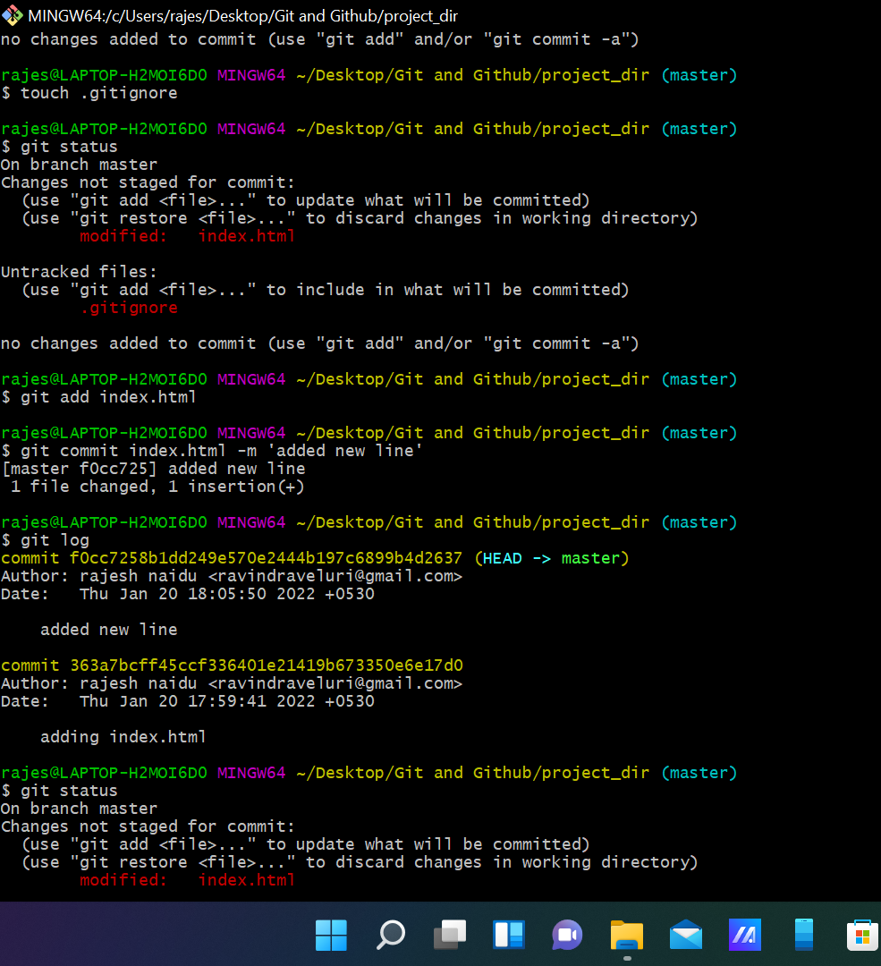

Here I created .gitignore using touch command and added text files to it using *.txt(all text files). After that staged and committed index.html. next logged all commits. Made changes to index.html manually. And checked git status.

14 - 20

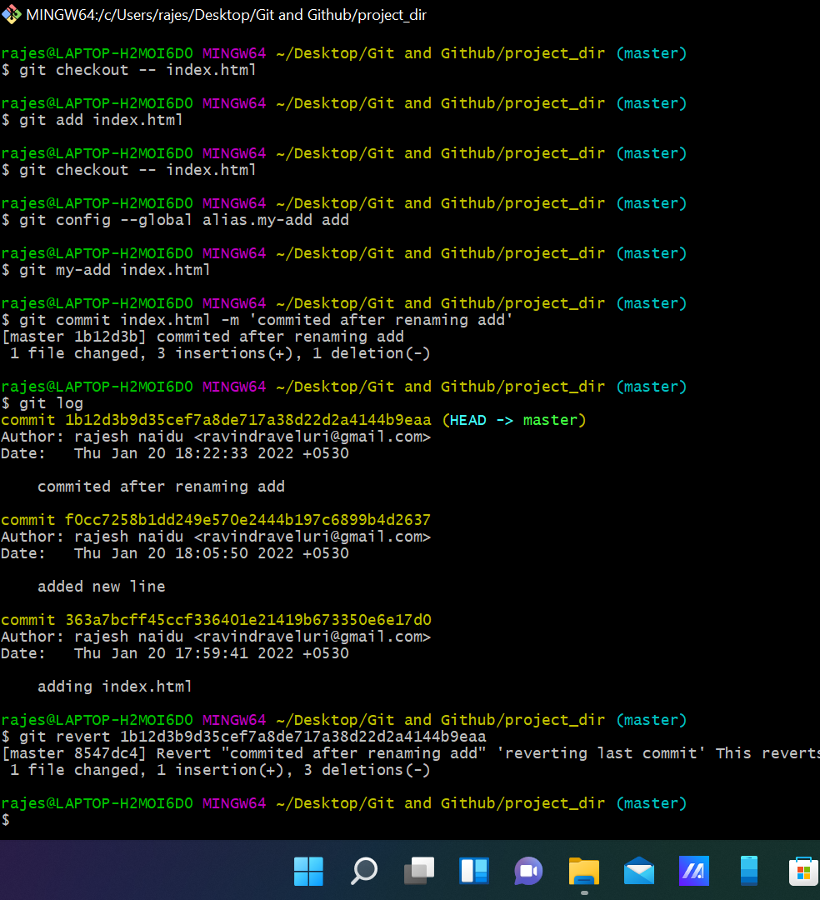

Reverted the changes made in the previous step using git command. And again modified index.html and staged the file and again reverted back the last stage. Renamed add command to my-add. Again staged and committed the file. Finally using git revert reverted the last commit.

**GIT BRANCHING**

SECTION-1 (HTML assignments)

21 - 27

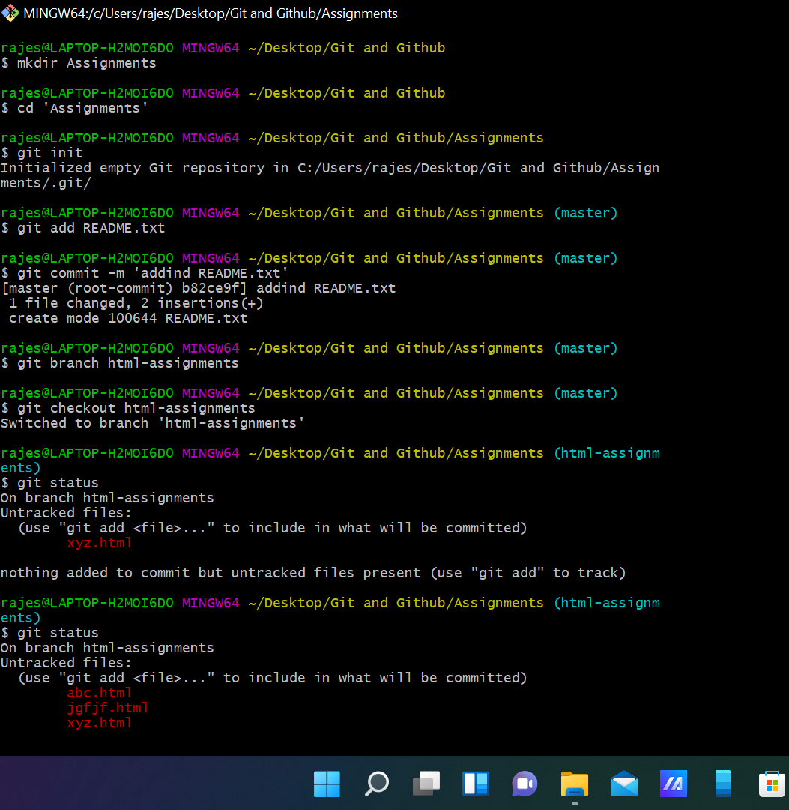

Created assignments directory initiated it added readme.txt manually and added few lines. Staged and committed the readme.txt file.created new branch html-assignments switched to it created some html files.

28 - 31

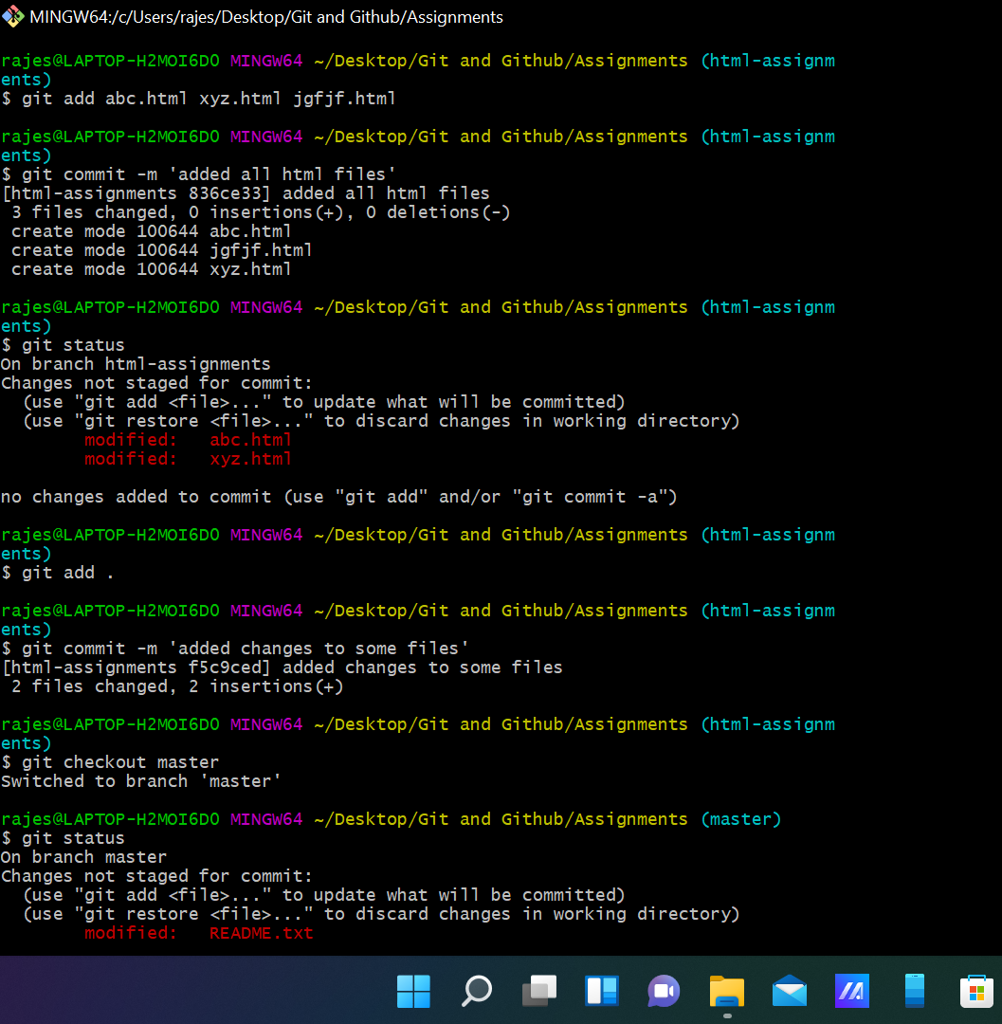

Committed those files and made some changes to some files and committed again. And checked out to master branch and made changes to readme.txt

32 - 37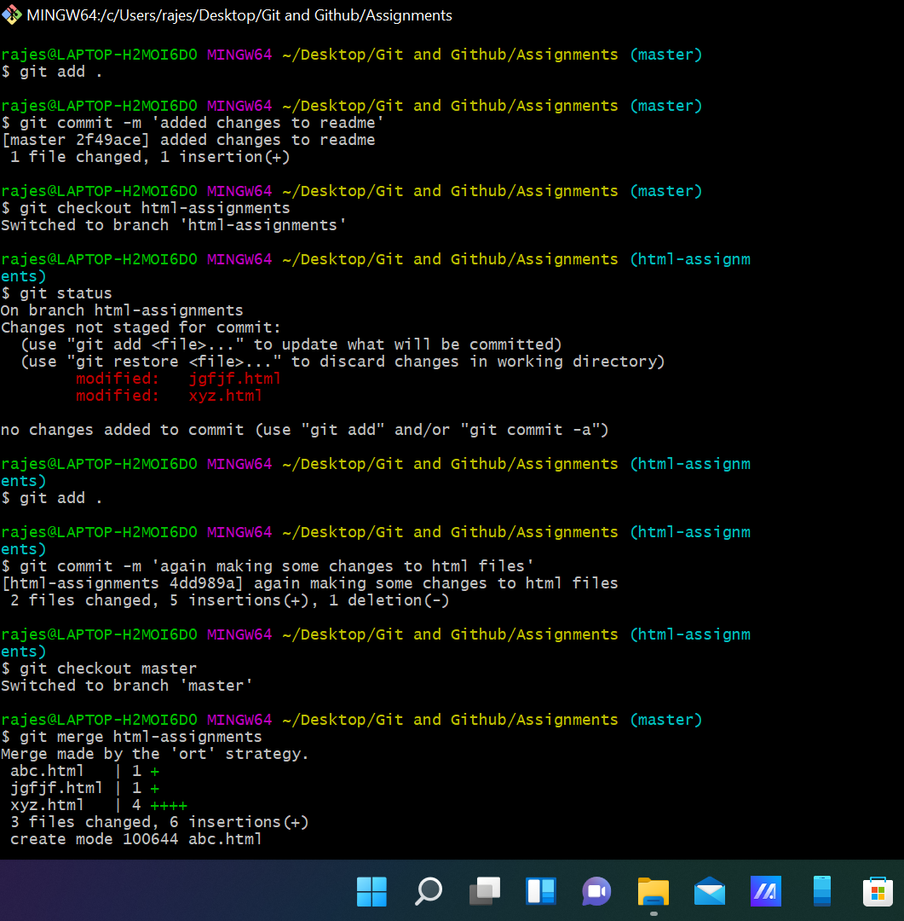

Committed the changes again switched to html-assignments and made some changes to some html files and committed them again switched to master and merged both the branches

38 deleting the html-assignments branch.

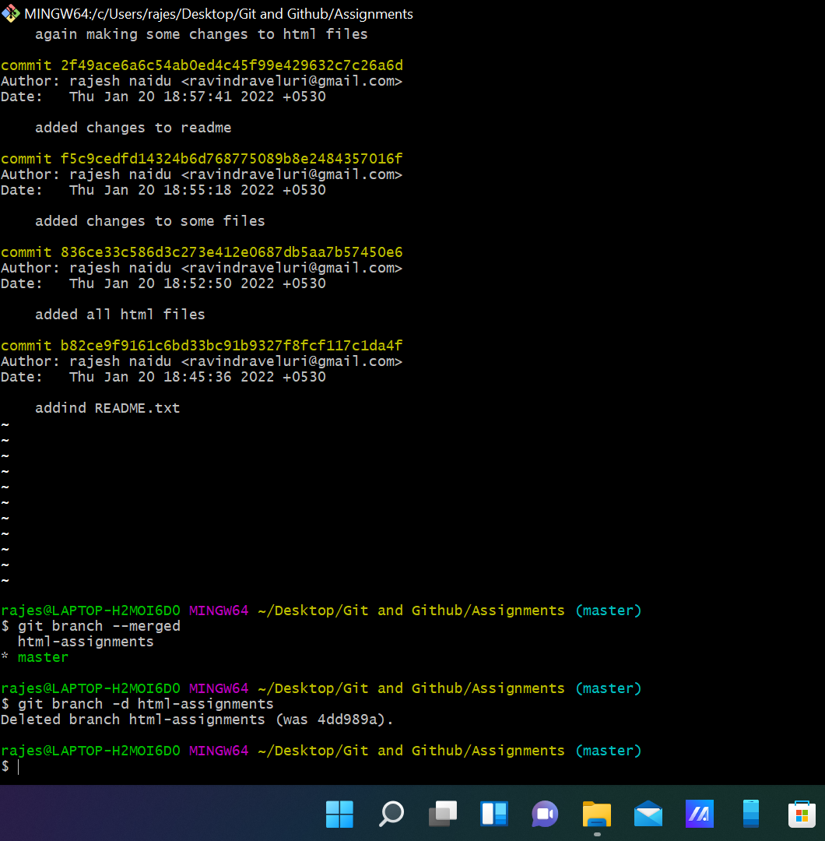

SECTION-2 - (CSS assignments)

1 - 6

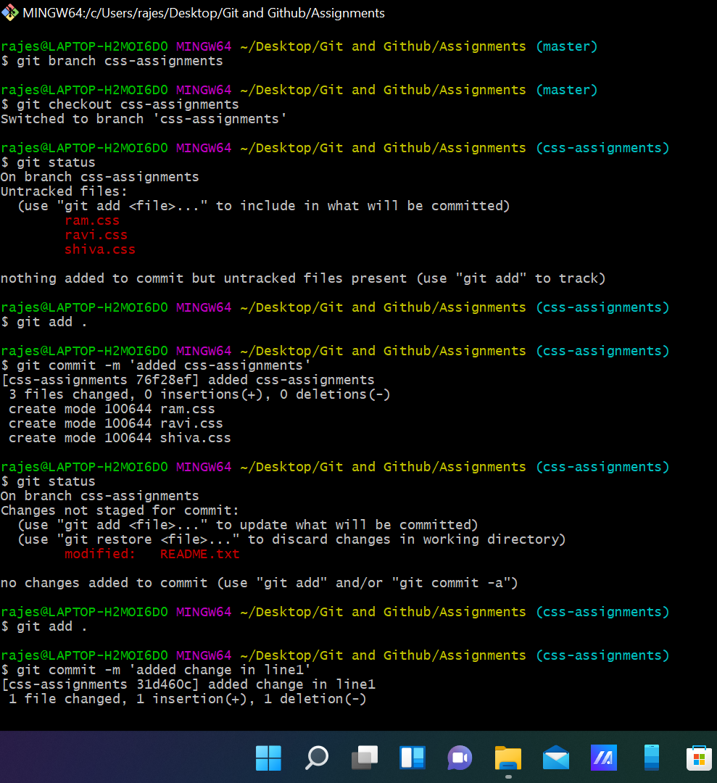

Created branch css-assignments and switched to it added css files manually and committed them and made changes to readme.text file on line 1 and committed them.

7 -

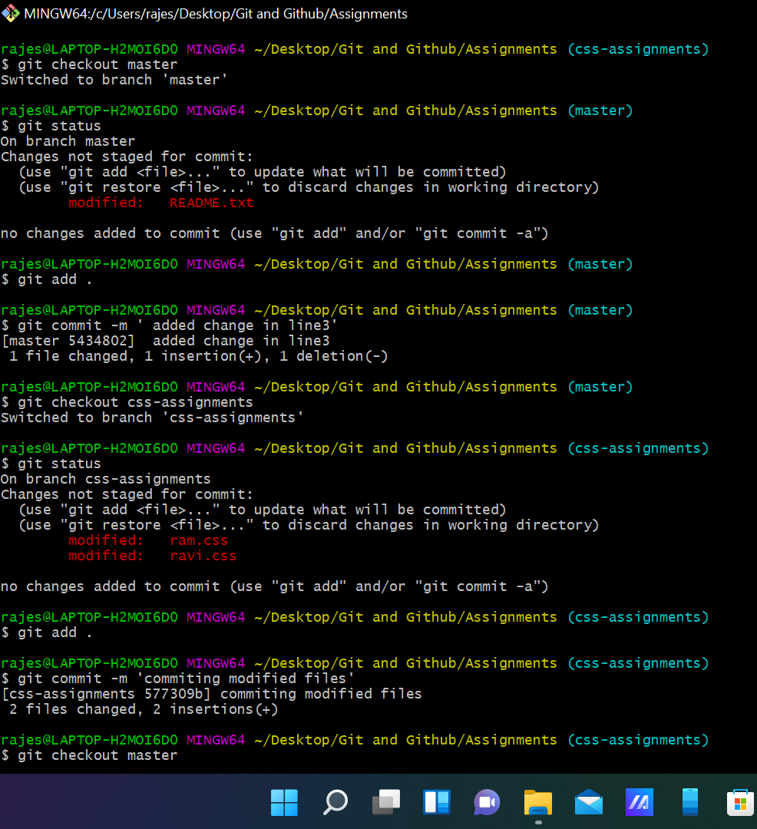

Switched to master branch and made changes to readme.txt in line 3 and committed. And switched to css-assignments branch and made some file changes and committed them and switched to master.

And in below SS merged master and css-assignments branches and then deleted css-assignments branch

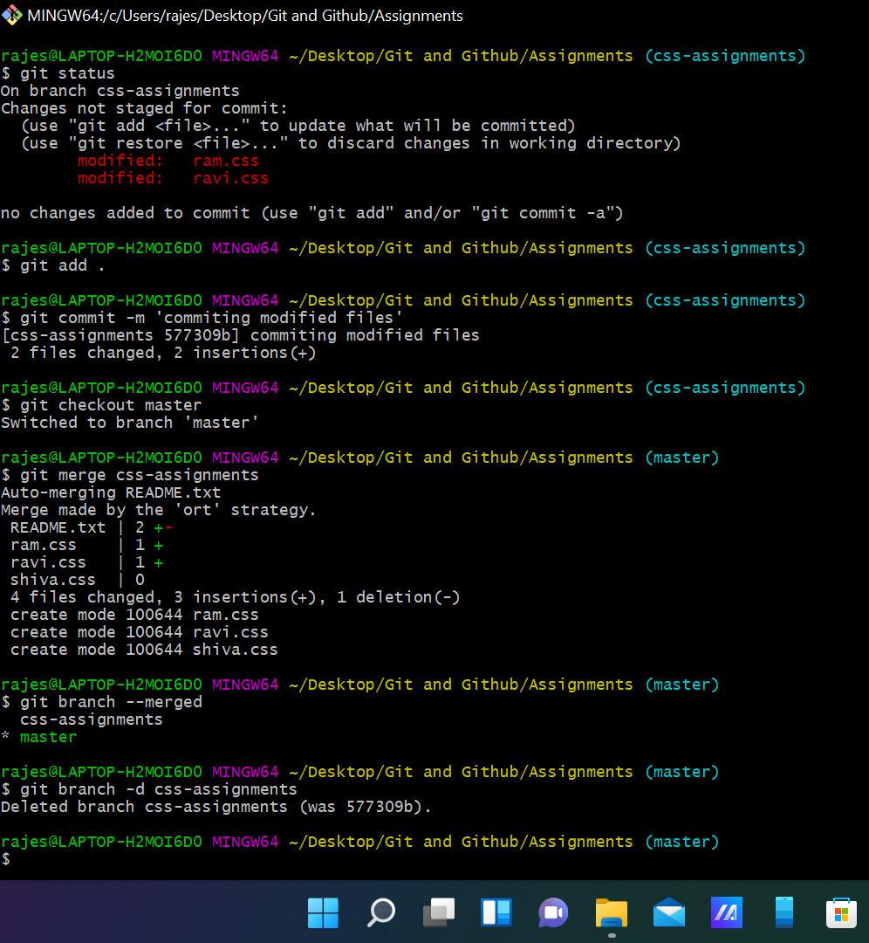

SECTION-3 - (JavaScript assignments)

1 - 6

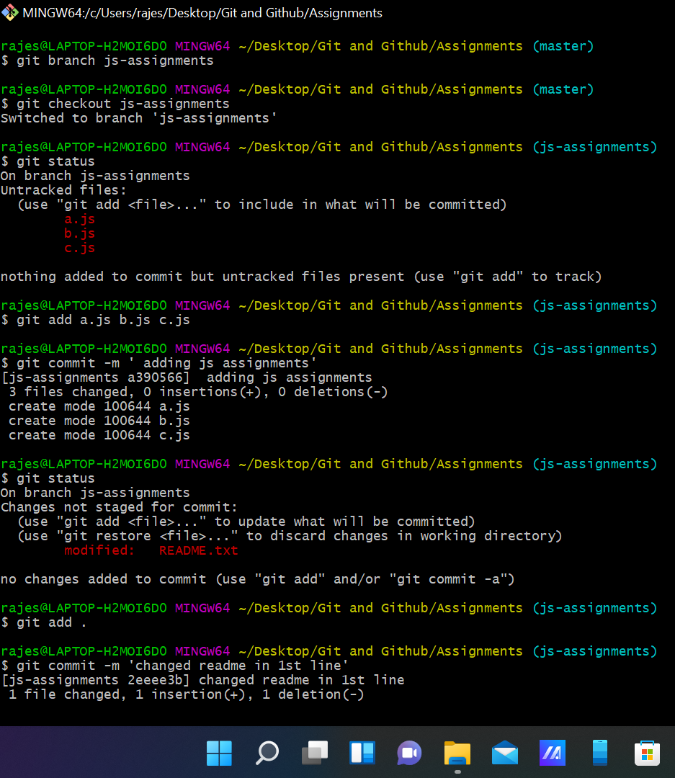

Created js-assignments branch and switched to it. Created js files manually and committed them and made changes to readme file in js-assignments branch and committed it.

7 - 11

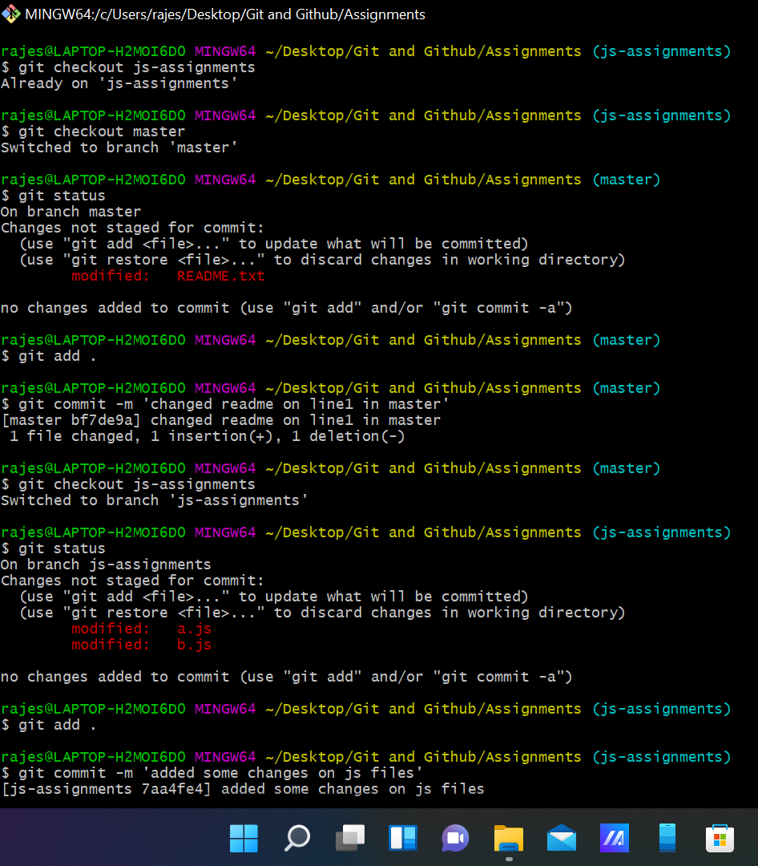

Switched to master and made changes to readme file and committed I and again switched to js-assignments and made few file changes and committed them. Again switched to master branch amd merged both branches and deleted js-assignments.

**GIT REMOTING**

SECTION-1 (Pushing assignments to remote repository)

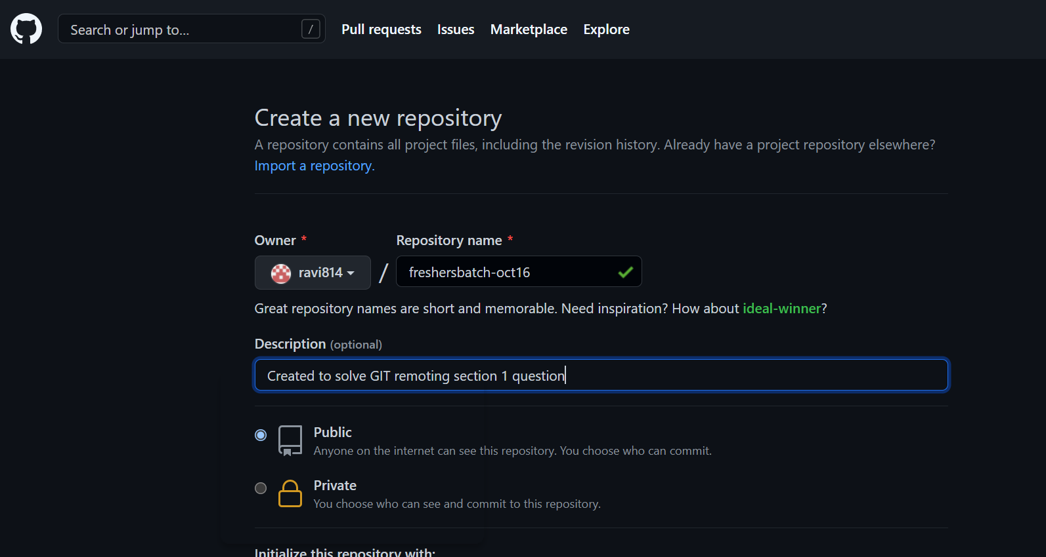

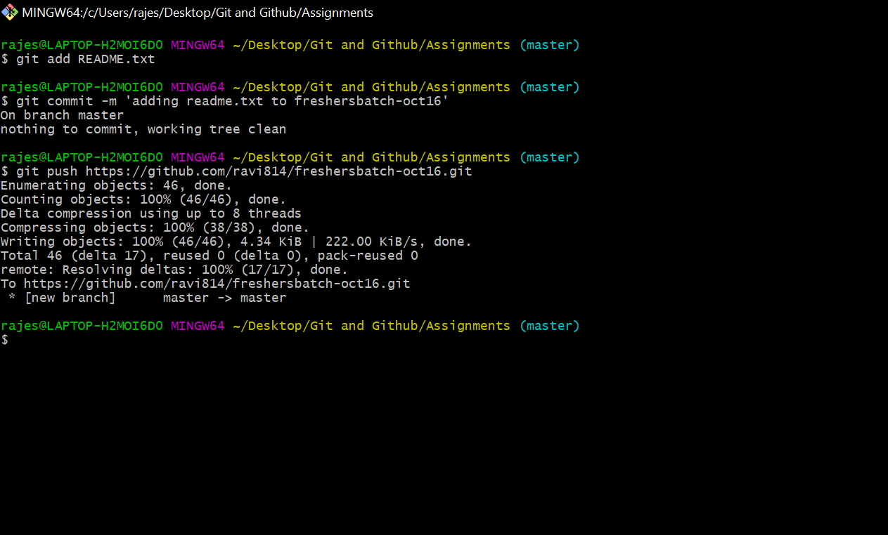

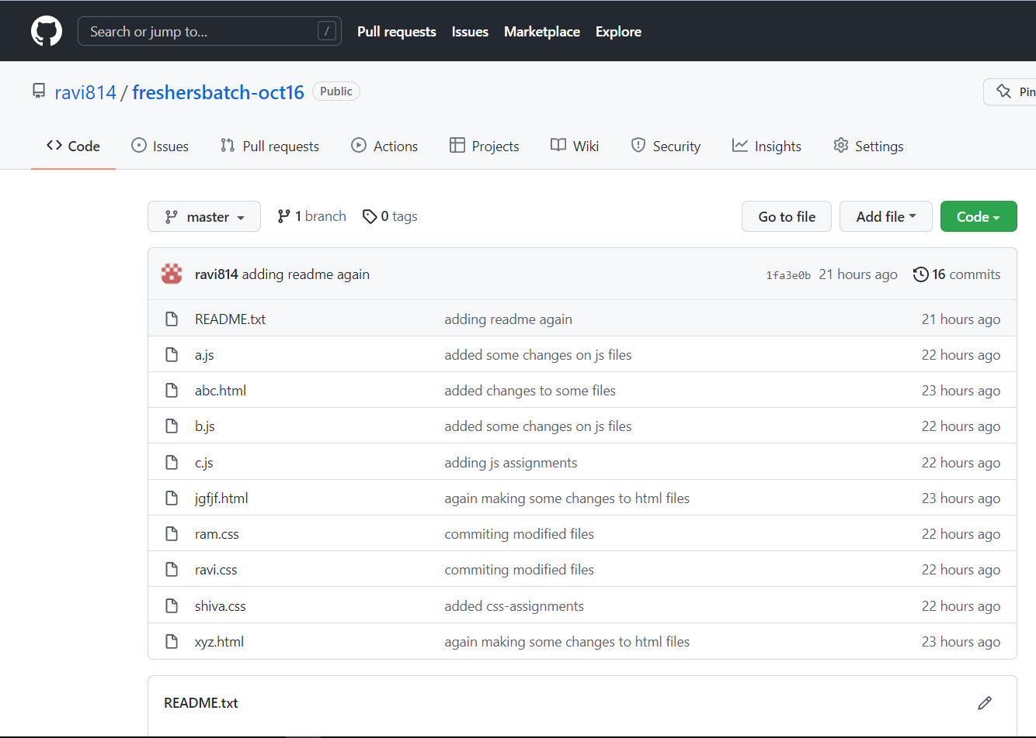

SECTION-2 (Pushing source code to remote repository using Eclipse GIT plugin)

ANS)

At first I have created a repo in github and copied that link and now in eclipse I searched for git repositories in perspective and added this github copied link.

After that I colned the repo th eclipse. And then created new java project sampleproj and right clicking on the project going to teams and selecting shared teams this box appears.

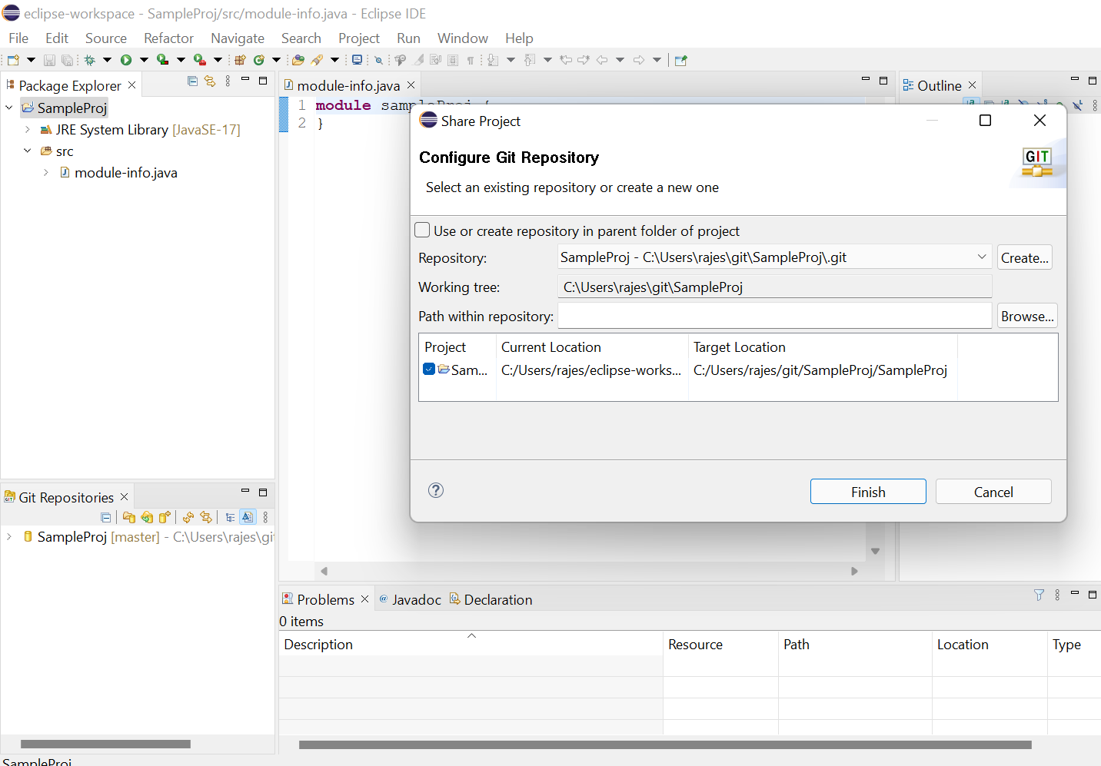

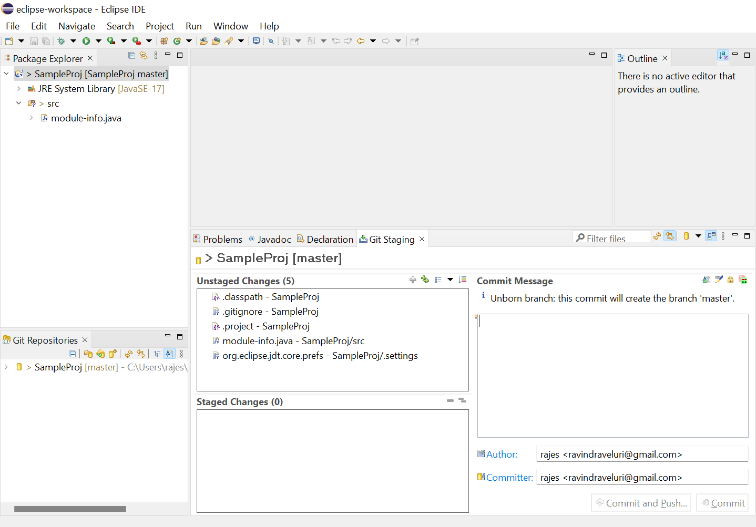

Here I have dragged and dropped all the files from unstaged to staged and then adding commet message. After that clicked on commit and push.

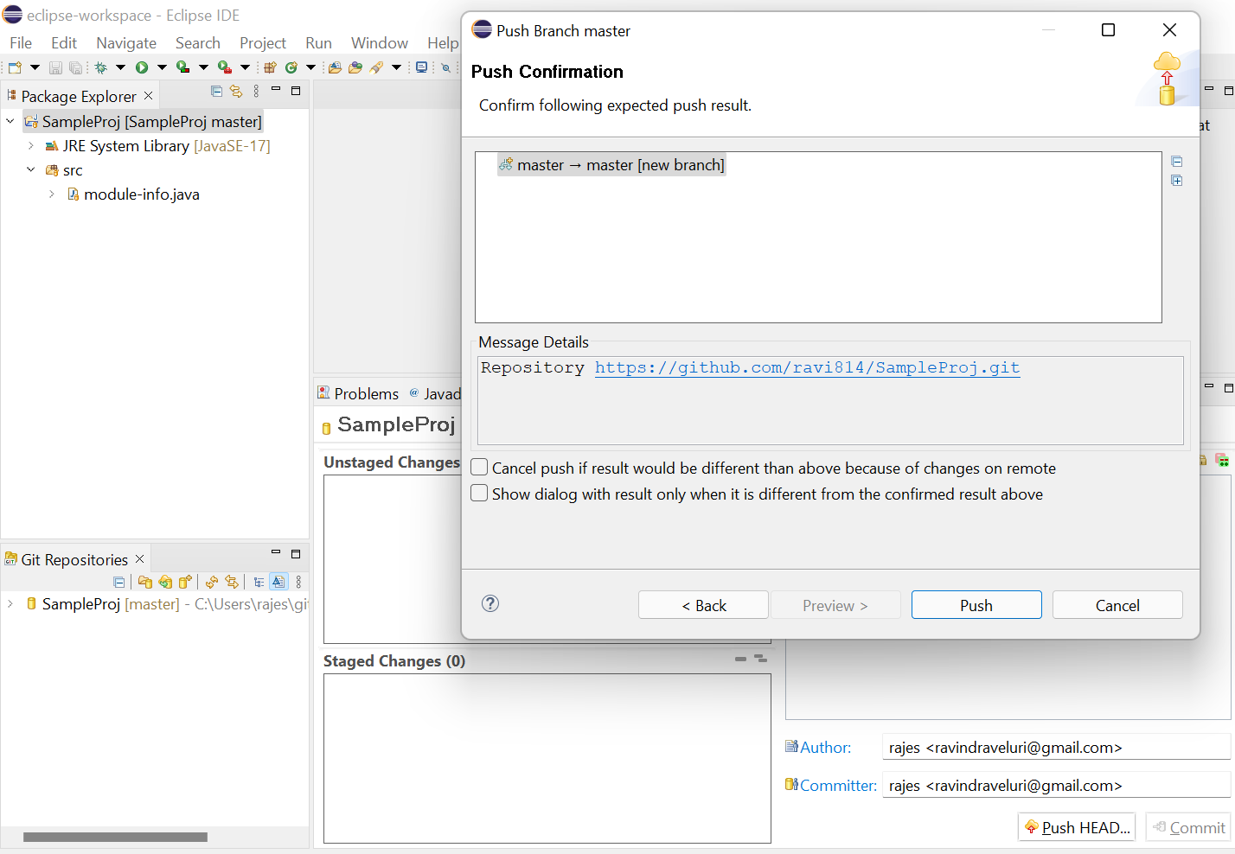

While giving username and password I got error after that I generated token and resolved it. And now it got pushed.

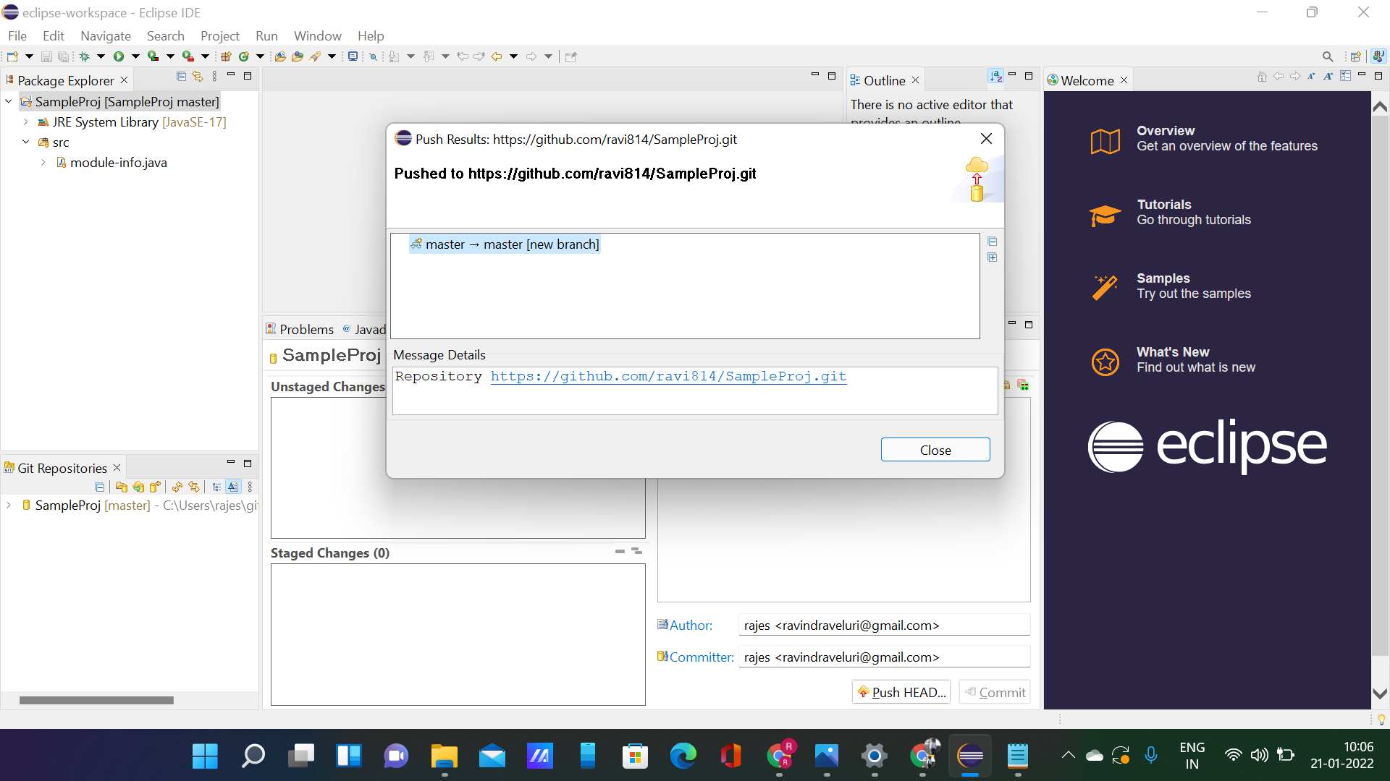

Here we can see that it got pushed to my git hub repo SampleProj.git